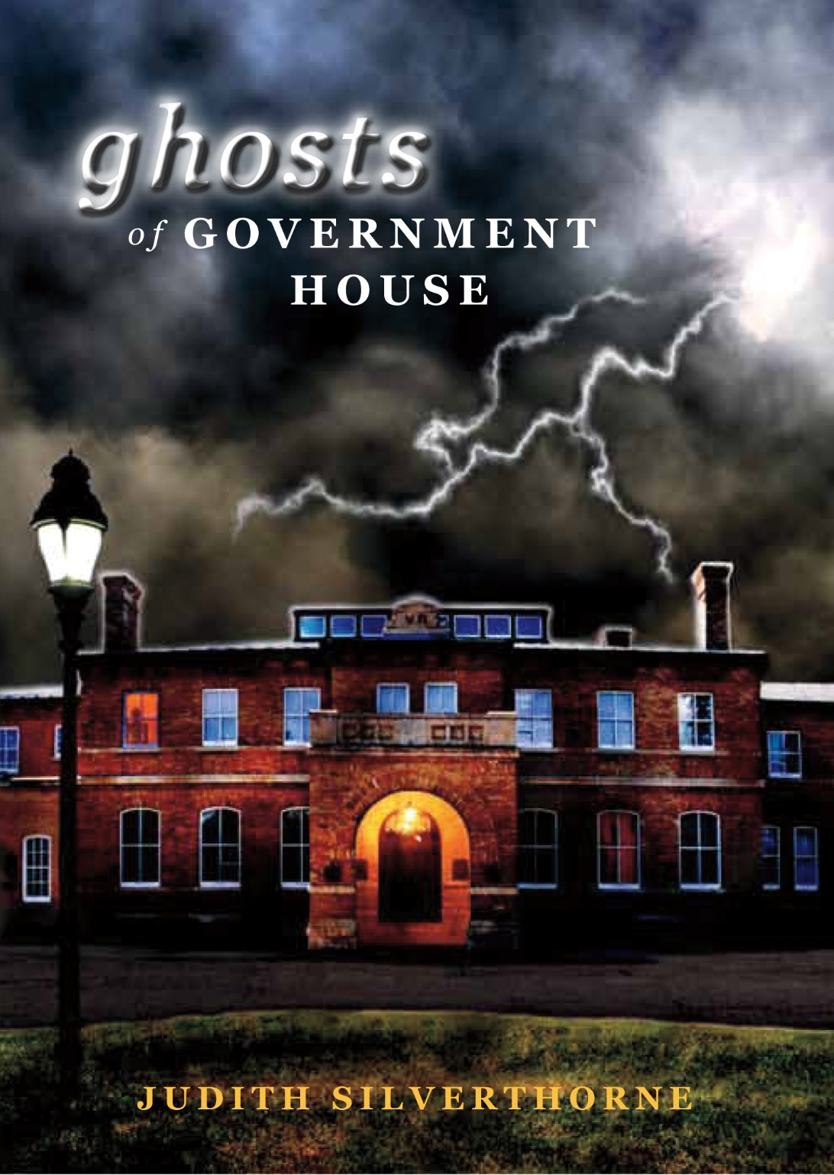

GHOSTS OF GOVERNMENT HOUSE

JUDITH SILVERTHORNE

Novel Study Guide
A Novel Study Guide

By Lori Saigeon

GHOSTS OF GOVERNMENT HOUSE

JUDITH SILVERTHORNE

A Novel Study Guide

By Lori Saigeon

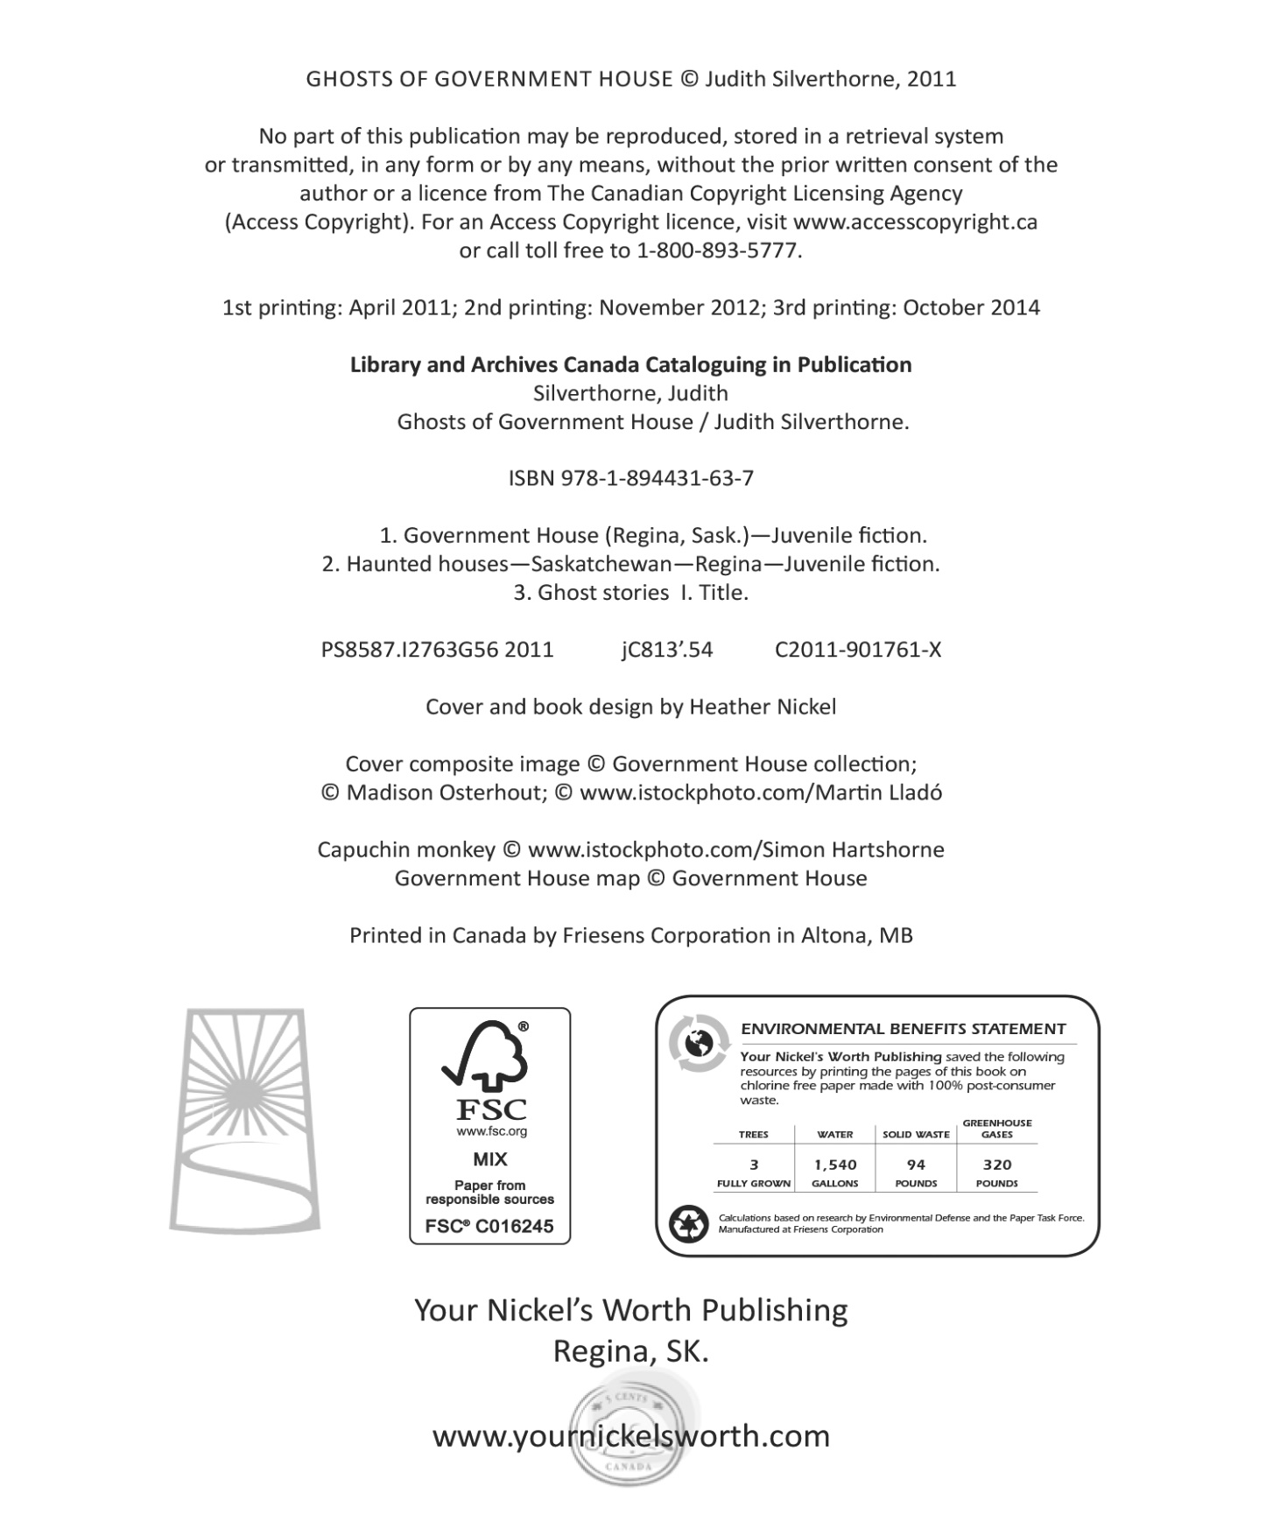

TABLE OF CONTENTS
About the Author . . . . . . . . . . . . . . . . . . . . . . . . . . . . . . . . . . . . . . . . . . . . . . 4
Introduction & Message from the Author . . . . . . . . . . . . . . . . . . . . . . . . . . . 5
Organization. . . . . . . . . . . . . . . . . . . . . . . . . . . . . . . . . . . . . . . . . . . . . . . . . 6
Connection to the Saskatchewan Curriculum Guide . . . . . . . . . . . . . . . . . . . 7
Chapter Summaries . . . . . . . . . . . . . . . . . . . . . . . . . . . . . . . . . . . . . . . . . . . . 9
Discussion Questions ………….. . . . . . . . . . . . . . . . . . . . . . . . . . . . . . . . . . 13
Novel Study, Chapter by Chapter (This printer-friendly material includes
ideas for presentation of the novel, and rubric for peer evaluation) . . . . . . . .17

ABOUT THE AUTHOR

Judith Silverthorne is a multiple-award winning Canadian author of more than a dozen books, many of which are children's novels, with one translated into Japanese, plus two adult non-fiction biographical books. Her two series of books; the “Secret” series and the “Dinosaur” series, both of which are used as supplemental reading in the education systems. Honouring the Bison, published in 2015, is her first picture book. Her first Young Adult novel, Convictions, is available in 2016.

She has also written several hundred articles and columns for newspapers and magazines and has worked as a journalist, freelance writer, editor, evaluator, researcher, curator, book reviewer, scriptwriter, television documentary producer and arts administrator.

The love of nature, people and history inspire Judith Silverthorne’s writing and help shape many of her award-winning books. Saskatchewan-based, she travels the world acquiring knowledge of cultures and societies, exploring mysteries, experiencing significant events and the everyday lives of people, which she weaves into her numerous stories.

In addition Judith teaches writing classes, and has presented hundreds of readings and writing workshops at libraries, schools and other educational institutions, as well she has given numerous presentations at conferences. She’s currently at work on several more children’s novels and her first adult historical novel. For more information about Judith, visit her website: www.judithsilverthorne.ca.

A MESSAGE FROM THE AUTHOR
Why I wrote Ghosts of Government House
I have a deep appreciation for Saskatchewan history and an inquisitive nature about people who lived in the past. I’m particularly drawn to stories of the inexplicable and the possibility of another realm of existence that we can’t readily see. For years, I enjoyed visiting Government House and learning of its transformations from a residence for various Lieutenant Governors to a war veteran’s hospital and then as an adult education centre and finally a museum.

During my numerous visits, I began to hear stories from staff and others who had experienced strange happenings there that couldn’t be explained by any normal reasoning. As I investigated more, I found that these unusual incidents were being attributed to a ghost or several ghosts. On one of my research trips to Government House, I met two adventurous ten-year old girls who were fascinated by the same ghost stories and who had started their own ghost detecting agency. They inspired me by their diligence and acceptance.

I couldn’t resist the challenge of writing about the rich history of this beautiful building and its occupants by introducing ghosts from several time periods in the telling of the story. I wanted to share my love of history with children in the hopes they would learn about what has gone before in a fun and intriguing way that might peek their further interest in exploring the past as well. I hope I have done so.

Judith Silverthorne

INTRODUCTION
PLOT SUMMARY Sam (Samantha) and Jensyn (J.J.) are two friends who share a fascination with ghosts and become interested in the history of Government House in Regina. They are determined to prove to Sam’s brother, Gabe, that ghosts exist there, and that they have heard and, hopefully, that they have seen them.

ORGANIZATION
Within this guide you will find a variety of activities intended to help readers appreciate and understand the novel, Ghosts of Government House. Literary qualities are considered, comprehension is examined, and connections to the curriculum and to readers’ real lives are pursued. Each teacher using this guide will be able to choose those exercises that best suit the needs of her or his students. We encourage you to add other activities as well.

First, you will find some introductory comments about this novel, including some information about the author, why Judith Silverthorne wrote the book and a plot summary.

Second, you will be able to read the curriculum connections that are addressed by the study of this novel. We have included connections from grades 3-6, as most students reading the novel will be in one of these grades. There are general connections to the Saskatchewan curriculum, as well.

Grouped together for your use next are chapter summaries for every chapter in the novel, followed by discussion questions, also organized by chapter. These are formatted to be used by students as journal response questions, if you so choose.

Lastly, you will find a printer-friendly version of a novel study that can be used as a whole or in parts with your students. The novel study addresses such literary elements as literature group planning, plot, character, comparisons, connections, vocabulary and planning and evaluating a presentation of the novel.

CONNECTIONS TO THE
SASKATCHEWAN CURRICULUM GUIDES

General:
Students demonstrate the understandings, abilities, and dispositions necessary to learn from subject discipline studies, cultural experiences, and other ways of knowing the world. Such ways of knowing support students’ appreciation of Indigenous worldviews and learning about, with, and from others. Students are able to engage in inquiry and collaborate in learning experiences that address the needs and interests of self and others. Through this engagement, students demonstrate a passion for lifelong learning. Students possess a positive sense of identity and understand how it is shaped through interactions within natural and constructed environments. They are able to nurture meaningful relationships and appreciate diverse beliefs, languages, and practices from the First Peoples of Saskatchewan and from the diversity of cultures in our province.

Social Studies:

Describe the origins of the cultural diversity in Saskatchewan communities (grade four); Analyze the evolution of Canada as a multicultural nation (grade five); Evaluate and represent personal beliefs and values by determining how culture and place influence them (grade six).

General Literacy Goals:

Identify strengths in viewing, listening, reading, speaking, writing, and other forms of representing. Set goals to enhance the development and improvement of the skills and strategies in viewing, listening, reading, speaking, writing, and other forms of representing and take steps to achieve goals.

English Language Arts, Grade Three:

Comprehend and respond to a variety of grade-level texts (including contemporary and traditional visual, oral, written, and multimedia) that address: identity, community, social responsibility, and make comparison with personal experiences. Listen to and understand information, identify main ideas and supporting details, compare different ideas and points of view, and explain connections made between texts heard. Read fluently and demonstrate comprehension of grade-appropriate fiction, script, poetry, and non-fiction from various cultures and countries and explain reactions and connections to texts read.

English Language Arts, Grade Four:

Comprehend and respond to a variety of grade-level texts (including contemporary and traditional visual, oral, written, and multimedia texts) that address: identity, community, social responsibility and support response with evidence from text and from own experiences. Listen, summarize, paraphrase, and evaluate what was listened to and draw conclusions. Read for various purposes and demonstrate comprehension of grade-appropriate fiction (including stories and novels), scripts, poetry, and non-fiction (including magazines, reports, instructions, and procedures) from various cultures including First Nations and Métis and countries (including Canada).

English Language Arts, Grade Five:

Analyze and respond to a variety of grade-level texts (including contemporary and traditional visual, oral, written, and multimedia texts) that address identity, community, social responsibility. Read and demonstrate comprehension of a range of contemporary and classical grade-appropriate fiction, script, poetry, and non-fiction (including magazines, reports, instructions, and procedures) from various cultures including First Nations, Métis, and Inuit and countries (including Canada).

English Language Arts, Grade Six:

View, listen to, read, comprehend, and respond to a variety of texts that address identity, social responsibility, and efficacy. Select and use appropriate strategies to construct meaning before (e.g., considering what they know and need to know about topic), during (e.g., making connections to prior knowledge and experiences), and after (e.g., drawing conclusions) viewing, listening, and reading. Use pragmatic (e.g., function and purpose of texts), textual (e.g., form/genre, sequence of ideas), syntactic (e.g., word order and emphasis on particular words), semantic/lexical/ morphological (e.g., capture particular aspect of intended meaning), graphophonic (e.g., sound-symbol patterns and relationships), and other cues (e.g., the speaker’s non-verbal cues) to construct and confirm meaning. Listen purposefully to understand, respond, and analyze oral information and ideas from a range of texts including narratives, instructions, oral explanations and reports, and opinions. Read and demonstrate comprehension and interpretation of grade-appropriate texts including traditional and contemporary prose fiction, poetry, and plays from First Nations, Métis, and other cultures.

CHAPTER SUMMARIES

CHAPTER ONE
(PAGES 13-25)

SUMMARY: Sam and J.J. are enjoying a tour of Government House with a community club one evening when they decide to hang back from the group going into the interpretive centre, and stay in the old, restored house area. After the door closes, the lights suddenly go out and they hear an odd sound of footsteps. Realizing that the footsteps go through a closed door, the girls are spooked and leave the house area. Catching up with their guide, they find out that she has no knowledge of the lights going out. Luckily Sam’s brother is waiting for them to walk them home. Hurrying home because J.J. is late, Gabe discovers the girls think they have had contact with a ghost, but he doesn’t believe them. The girls make a bet with Gabe that they will prove that ghosts exist in Government House. Upon arriving home, Sam and Gabe are pleased to see that their Grandma Louise has arrived for a surprise visit. She shows a lot of interest in Sam’s adventures in Government House.

CHAPTER TWO
(PAGES 26-32)

SUMMARY: Sam wakes up to J.J. urging her to get back to Government House to continue their ghost research. The internet tells them about Howie, who some people say haunts the house. Grandma Louise once again shows interest in the ghosts and the girls convince her to take them back for more exploration. Before they leave Government House, J.J. brings up her deceased mom. Grandma Louise is sympathetic and they talk about having lost loved ones; J.J.’s mom and Grandpa Frank, Grandma Louise’s husband.

CHAPTER THREE
(PAGES 33-46)

SUMMARY: Immediately upon entering Government House again, the girls see a young injured man in an old-fashioned wheelchair. The girls approach the man but he is grouchy and unfriendly. Realizing that Grandma Louise couldn’t see the man, the girls think that he might be a ghost, as well. The commissionaire at the front door tells the girls about the strange happenings that people have experienced and attributed to ghosts. He suggests that they talk to Kathryn, who has worked at Government House for eight years. Sam ad J.J. soon meet Kathryn but realize, when Grandma Louise arrives with the real Kathryn, their corporeal host, that the one they met was likely a ghost as well. No sooner do they recover from this shock, than they see a monkey fooling around on the chandeliers. He turns out to be the ghost of Jocko, a capuchin monkey who lived in Government House in its early days. As Grandma Louise and Kathryn continue the tour, Sam misplaces her magnifying glass which mysteriously shows up again. Could it be ghostly activity?

CHAPTER FOUR
(PAGES 47-57)

SUMMARY: As Sam, J.J., Grandma Louise and Kathryn continue their tour upstairs, Kathryn gives everyone more background about what events have been attributed to the ghost, who they think he was, and how he got his name of Howie. No sooner do the girls wonder what happened to the young man in the wheelchair, when he appears in the next room and J.J. hurries to take his picture. Quickly he disappears. The girls realize that Kathryn and Grandma Louise can’t see the young man, so Sam asks Grandma to keep Kathryn talking so they can investigate where he was and look for evidence that he had been there. As their host, Kathryn, moves ahead of them, the girls divulge to Grandma Louise that they have seen three or four ghosts and expect there might be more. She is amazed but not surprised and explains to them how children can sometimes see ghosts better than adults. Just as the girls wish for a child ghost, they hear mysterious, childish laughter and hear running footsteps.

CHAPTER FIVE
(PAGES 58-66)

SUMMARY: As the girls try to ask Kathryn about children who lived in Government House in the past who could possibly be the ghost they just heard, she shows them a mirror that shimmers unexplainably. Very soon the girls met Ben, who doesn’t realize he is a ghost. He lets them know about his governess as well as his little brother, Robbie. While heading out for lunch, the girls let Grandma Louise in on all the ghosts they’ve seen, then wonder if they could help them all meet up so they wouldn’t be lonely. The girls agree to go back to Government House to try to make contact with Howie. In the meantime, they check J.J.’s digital camera for the photo they took of Sheldon, the young man in the wheelchair, and they are in for a surprise. Just before sleep while having a slumber party at Sam’s, Ben pays the girls a shocking visit which makes them wonder if they want to continue with their ghost hunting.

CHAPTER SIX
(PAGES 67-76)

SUMMARY: This chapter opens with Sam and J.J. on their way with Grandma Louise to Government House to prove to Gabe that the ghosts exist. Right after their arrival, they and their new host, Robin, are shocked to find a mess in the front of the main house. Robin gets the commissionaire, who pronounces it to be the work of Howie. The possibility of ghosts upsets Robin as well as Gabe, although neither of them believe yet that ghosts are playing pranks. When the girls lead everyone else upstairs, they are disappointed to find out that Gabe can’t see Sheldon, who is there. However, right away Gabe himself spots Howie, thinking he’s real. The girls are more determined than ever to ensure Gabe believes in the ghosts.

CHAPTER SEVEN
(PAGES 77-86)

SUMMARY: Sam and J.J. continue scouting around the house and run into Sheldon, who is more talkative than before. From him, they learn that he has only just started seeing Howie, as well, and also that he can see the dog ghost. Sheldon informs the girls that he is a World War II veteran and he is astounded at how little they seem to know. As soon as they start asking about him going home, Sheldon fades away. As a storm gathers, including lightning and thunder, the lights in the house go out and Howie appears to the girls. They call him Mr. Cheun Lee and finally have a short conversation with him. “Howie” informs them that he is from China and that his family is still there. Again, he doesn’t seem to know he is a spirit. Suddenly, Jocko the monkey steals Gabe’s hat and fools around with it, swinging on the chandeliers. Gabe is still not convinced it’s a ghost, but he can’t explain why his cap seems to be moving on its own!

CHAPTER EIGHT
(PAGES 87-96)

SUMMARY: Sam and J.J. carry on a conversation with Ben. He has finally realized that he’s a spirit, but he is sad about it. Gabe is still not convinced the ghosts are real but thinks that the girls are trying to fool him for some reason. Grandma Louise encourages him to know that his belief in ghosts may come back. As Sam and J.J. begin puzzling over why Ben can see some ghosts but not others, Grandma Louise suggests that it may be due to several reasons; one - that they lived in different parts of the house at different times; and two - that perhaps they can see only what they already know. Robin can certainly see the ghosts but they scare her. A crash in the billiard room proves to be a mess of cues and balls, then another series of sounds from the drawing room turns out to be another mess. Grandma Louise suggests that maybe that’s enough ghosts for one day, but everyone hears a music box playing in the nursery and Sam goes to talk to Madeleine. J.J. comes looking for her to take her back to Grandma Louise and Gabe; just then they see movement in one more bedroom.

CHAPTER NINE
(PAGES 97-106)

SUMMARY: Robin and the girls check the bedroom where they saw the movement. It turns out that no ghost is there, but the chamber pot has been moved on top of the mantel. Robin notes that this has happened before. Right away, they hear Cheun Lee slip-slapping down the hall. They follow him and see him in his little bedroom, becoming emotional over a photo of himself in China with his wife and children. Robin lets the girls know that this room is usually an office, but they are seeing it the way it was when Cheun Lee lived there. They feel bad for Cheun Lee, and J.J. feels a kinship to him because of how she misses her mom. Grandma Louise reminds her that her mom is likely with her. Before they know it, they hear water running and discover that the tub in the bathroom has water in it, even though it’s not connected to the pipes! In an instant, the water disappears but Gabe is still skeptical about ghosts and thinks the girls have somehow played another trick on him. Grandma Louise observes that the ghosts all seem to be lonely, although they seem to be hanging around Government House because they all loved it there in life. The girls decide to unite the ghosts, and get them all together and introduce them. Madeleine, the nanny appears to want to look after Sheldon, and Ben and Cheun Lee prepare to play Mahjong.

CHAPTER TEN
(PAGES 107-114)

SUMMARY: As Sam, J.J., Grandma Louise, Gabe and Robin regroup and discuss how the ghosts are all together and know each other now, they are spoken to by a caretaker-type man who cleans up the overturned plant and continues on to the basement. He introduces himself as George Watt, whom Robin divulges was the caretaker at Government House over one hundred years ago! He claims he is going to check on the mushrooms, which were grown in the basement, but Robin informs everyone that mushrooms haven’t been grown there for decades. Will they check out the ghosts in the basement? No, the girls decide to leave the rest of their ghost detecting for another time. At last, Gabe decides to prove Cheun Lee is real but when he tries to shake his hand it passes right through him. Gabe runs home… believing in ghosts, we think. The Sam and J.J. Ghost Detective Agency is born.

DISCUSSION QUESTIONS

Answer these questions aloud in class, in your journal or on another separate paper. (These questions may be used singly or in combination, and may be photocopied directly for use in the classroom.)

Chapter 1:
The girls hear a strange sound in the dark at Government House. They think it might be a ghost.
Do you agree or disagree? Explain.

Grandma Louise seems very interested in what Sam heard.
What might be the reason for this?

Chapter 2:
Grandma Louise helpfully is going to take the girls to Government House.
What do you think her interest in the ghost might be?

The author says that “Sam froze,” when J.J. mentioned her deceased mom. What was Sam likely thinking?

Chapter 3: The young injured man in the wheelchair acts grouchy and a little funny towards the girls.
What do you think makes the girls continue to try to talk to him?

The girls also meet an unexplained tour guide, Kathryn, and see a monkey they think is Jocko.
What do you think is going on in Government House?

Near the end of this chapter, we get further evidence that the girls are encountering ghosts. What is this evidence?

Take a moment to add any character traits to your lists for Sam and J.J.

Chapter 4:
How did “Howie” get his nickname?

What does the tour guide, Kathryn, reveal to us about Government House that might explain Sheldon’s presence?

Before reading on, take a minute to jot down what you know about the four would-be ghosts so far; Howie, Sheldon, Kathryn and of course, Jocko. Do you notice anything they might have in common?
Chapter 5:
On page 61, just after the girls meet Ben, the author tells us that, “Suddenly it was too much.”
What do you think she means?

Grandma Louise suggests the girls make a timeline of the ghosts they have seen so far. How might it look? Try one of your own. Use the one below as a start.

1936-38

Jocko Howie Ben? Sheldon Kathryn?
(Cheun Lee)

At the end of the chapter, the girls have a small crisis of second thoughts. What caused it?

What might help them continue on their ghost search?

Chapter 6:
The girls finally get Gabe to Government House to prove to him that the ghosts are real.
What funny thing happens to Gabe regarding Howie?

The girls can’t seem to get the ghosts to appear.
Why do you think that is?

Look again at your character traits for Sam and J.J. Add to the lists, if you can.

Chapter 7:
Stop on page 80, when Sheldon fades away.
Can you place Sheldon on your timeline now?

What event happens to Gabe that might help him believe in the ghosts? Do you think it will?

Chapter 8:
On page 89, Grandma Louise gives a hint as to why Gabe possibly can’t see the ghosts. What do you think?

Five unexplained events happen in this chapter.
List them below, and across from each one, tell who (or what) you think is responsible for each, like in the chart below:
Event: Cause:
________________________ ______________________
________________________ ______________________
________________________ ______________________
________________________ ______________________
________________________ ______________________

Chapter 9:
The girls manage to bring the ghosts together. Why do you think this works?

List what each ghost would get out of having relationships with the others:
Jocko - ____________________________________________

Ben - ______________________________________________
Madeleine - _________________________________________
Sheldon - __________________________________________
Cheun Lee - _________________________________________

Chapter 10:
What event finally (hopefully) convinces Gabe of the existence of ghosts?

Near the end of this book, we have several hints that there may be a sequel (another book on this same topic and/or with these same characters). List these hints:
1) _______________________________________________
2) _______________________________________________
3) _______________________________________________

Ghosts of Government House
NOVEL STUDY
NAME ____________________________
Get Ready
Look over your book and answer the following questions.

1. What is the title? _________________________________

2. Who is the author? ________________________________
3. How many pages are there? _____________
4. How many chapters are there? ___________
5. Look at the title and front cover. Read the back cover. What do you think this book is going to be about?

_________________________________________________
_________________________________________________
_________________________________________________
6. Finish this sentence: I am looking forward to reading
this book because __________________________________
_________________________________________________
Planning

- Look over the book carefully again. With your literature group, decide how you will get the book read. You have from
_____________ to ___________ to read the whole book.
(date) (date)
That’s ______ days of reading time on the timetable.

Chapter 1 - _____________________________
Chapter 2 - _____________________________
Chapter 3 - _____________________________
Chapter 4 - _____________________________
Chapter 5 - _____________________________
Chapter 6 - _____________________________
Chapter 7 - _____________________________
Chapter 8 - _____________________________
Chapter 9 - _____________________________
Chapter 10 -_____________________________
- What will you do if you get behind? __________________
_____________________________________________

Chapter 1: First Impressions

- How do you feel about this book so far? _________________
__________________________________________________

2. What is the problem someone is facing? __________________________________________________
3. How do you think this problem will be solved?
__________________________________________________
__________________________________________________

4. Who do you like in the story so far? _____________________
Why? _____________________________________________
__________________________________________________
5. Ask four good questions about your book that you hope to answer as you keep reading:

1) _____________________________________________
2) _____________________________________________
3) _____________________________________________
4) _____________________________________________
Chapter 2: Sam and J.J.

Sam and J.J. are good friends, but they are very different from each other. Begin a list of character traits for each girl. Use phrases from the story to help you, and come up with your own words, as well.

Sam J.J.

Chapter 3: J.J.’s Word Watch

J.J. is thoughtful. Can you be thoughtful, too?
Choose 4 tricky or interesting words from the story.
Tell what they mean from the context.
If you are not sure, consult a dictionary.

WORD MEANING

1) _____________ ___________________________
___________________________
___________________________
2) _____________ ___________________________
___________________________
___________________________
3) _____________ ___________________________
___________________________
___________________________
4) _____________ ___________________________
___________________________
___________________________

Chapter 4: Sam’s Question Quizzer

Sam is curious and asks a lot of good questions. Your turn!

Write four good questions that you can answer from this story so far. Answer the questions with good sentences.

1) ______________________________________________
A) ______________________________________________
_________________________________________________
2) ______________________________________________
A) ______________________________________________
_________________________________________________
3) ______________________________________________
A) ______________________________________________
_________________________________________________
4) ______________________________________________
A) ______________________________________________
_________________________________________________

Chapter 5: Story Mapper

Jot down three ideas about the setting, the main characters in the story and at least three jot notes for each of the beginning, the middle and the ending of Ghosts of Government House.
Setting |  | Character
Beginning | Middle |  | Ending
Connections (text to self, text to text, text to world):
1)

2)

3)

Chapter 6: Character Catcher

Dream catchers “catch” bad dreams to keep them away from the sleeping one. A character catcher snags the most important characteristics of a person for all to read.

Choose a character from this novel, but not Sam or J.J. Write his or her name in the centre of the “Character Catcher.”

Think of or find words to describe your character and “catch” them in the “Character Catcher.” Write these words in the second “ring” of the catcher. Try to use interesting words – choose ‘ornery’ instead of ‘grouchy’; ‘joyful’ instead of ‘happy’, and so on.

On the outside of the catcher, tell what the character did or said that made you choose each word. E.g. Sheldon – moody – ‘”What’s it to you, anyway?” he growled.’ (page 50)

Chapter 7: Loss

Think about the many different characters in Ghosts of Government House (Sam, J.J., Grandma Louise, Sheldon, Ben, Cheun Lee).

Choose one character who experienced some kind of loss and write his/her name here: _______________________

Jot down how this loss affected this character, and how this person decided to deal with their loss:

AFFECT | SOLUTION

How have you handled a loss in your own life? Write your experience in losing a loved one, a pet, or even a treasured possession or a friend:

___________________________________________________
___________________________________________________
___________________________________________________
___________________________________________________
Chapter 8: Ghosts

This story tries hard to convince us, the readers, that ghosts really exist. What evidence is provided that they are real? List at least five examples from the story. Include the page numbers where you found the examples.

______________________________________________
______________________________________________

______________________________________________

______________________________________________

______________________________________________

______________________________________________

Does this novel help you to believe that ghosts may exist? Maybe you already believed in ghosts, or maybe you didn’t and you still don’t. Explain how you feel about whether or not there really are ghosts.

______________________________________________

______________________________________________

______________________________________________

______________________________________________
Chapter 9: Comparing Two Characters
Think about what you know about Sam and what you know about J.J. Look back on the notes you made about them in Section 4.

Use this Venn diagram to show what is alike about them and what is different about each. You may instead choose to compare Sam and Gabe, Sam and Grandma Louise, or Sheldon and Cheun Lee.
J.J.
BOTH

SAM
Chapter 10: Map
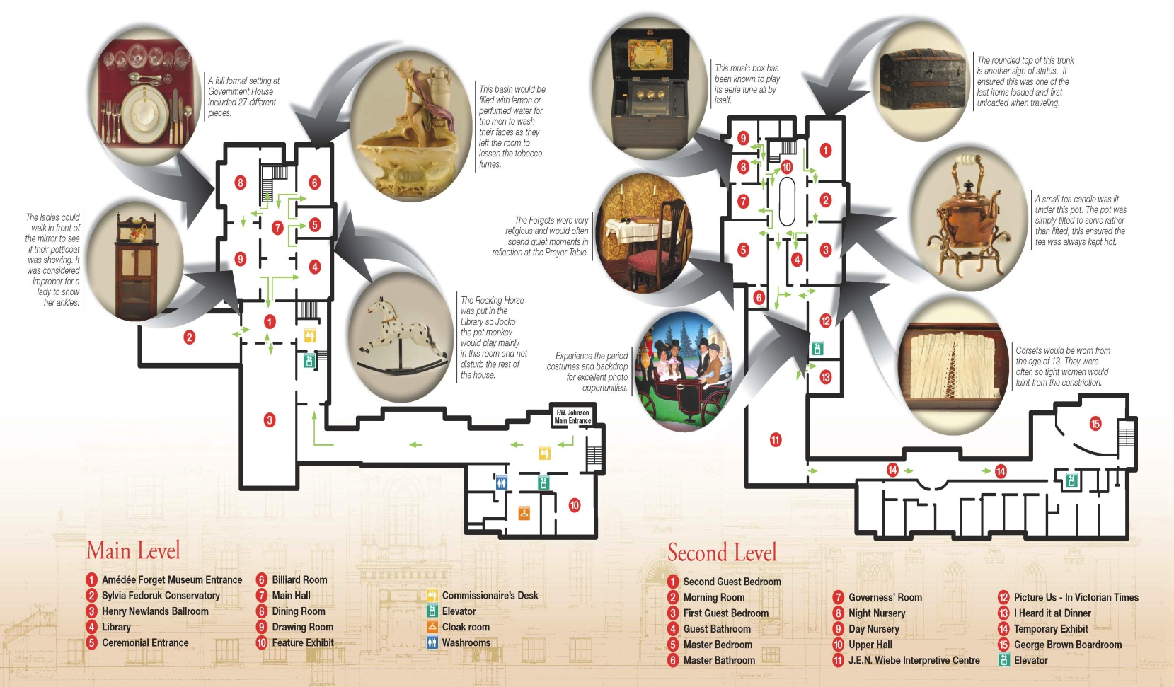
Below is the layout of Government House’s Main Level and Second Level

Using the following key, mark out where each ghost was seen and spoken to by the main characters, Sam and J.J:
Cheun Lee: CL
Howie: H
Sheldon: Sh
Ben: B
Madeleine and Robbie: MR

Where were the girls when they got all the ghosts together at the end of the story?
_____________________________________________________

Conclusions
- Did you enjoy this book? ___________________________________

- Why or why not? __________________________________________
__________________________________________________________
__________________________________________________________

- To whom would you recommend this book? ____________________

- Why do you think this person would enjoy Ghosts of Government House?
__________________________________________________________
__________________________________________________________

- Were there any surprises in this book? ____________________

- If so, what were they? _______________________________
__________________________________________________
7. Answer the questions you asked in Section 3, if you can:

- __________________________________________________
- ___________________________________________________
- ___________________________________________________

- ________________________________________________________
Planning a Presentation

You will be presenting this novel to the class on one of the following dates: ________________________________________
Think about what you are good at (writing, talking, singing, drawing, etc.)
Plan how you will show everyone the good and bad points about this book without giving away the whole story. You will want to interest your classmates in reading this book, but not tell everything!
You may choose one of the following:
- make a poster advertising the novel
- write a poem about the novel
- make a drawing of the dual photo that J.J. took of Sheldon in the morning room as well as the hospital room, at the same time
- write an interview to have with the author or a character in the novel
- make a brochure about your book
- sing a song about your book
- act out a part of the story
- do a pretend news report about your book
- the list of ideas is endless, limited only by your imagination!

To present my novel, I will _________________________________.
Reader’s choice of presentation (What did you decide?)
Use the following questions, your answers on previous pages and the rubric to help you.
What kind of book is this?
Who are the characters in your book?
What is the MAIN IDEA of the story?
What made the story COMPELLING (you couldn’t put it down)? Why should other people read this book?
What connections did I make with this book, and why?
Others…?
Marks Rubric for “Novel Study”

Name ___________________________ Date ____________________

Grading | 4. Excellent | 3. Adequate | 2. Fair | 1 Minimal | Total & Comments
Neatness and Organization | Ideas are presented in good order, printing/ word processing and extra additions are neatly completed | One or two ideas are out of order. Most of the writing and extra additions show care. | Many ideas are out of order. Writing and extra additions show average effort. | Ideas are not written in order. Writing and extra additions lack neatness and effort.
Visual Aids or extra additions (drawings, photographs, graphs, dressing up as a character, etc.) | A variety of three or more extra additions enhanced the presentation. | Two extra additions added interest to the presentation. | One extra addition helped the audience to understand the presentation. | No extra additions used to support the presentation.
Citations with page numbers from the novel (Where did I find the information) | Four or more citations. | Two or three citations. | One citation. | No citations are listed.
Oral presentation and audience contact | A clear voice, good expression and consistent eye contact kept your audience engaged. | A clear voice and much eye contact were shown. | Little eye contact and a small voice were shown. | Oral report was read from notes without giving eye contact. Small voice was shown.
Grammar, punctuation and spelling | Proper use of grammar, punctuation and spelling throughout. | Most of the writing shows correct use of grammar, punctuation and spelling. | Many sentences show errors in grammar, punctuation and spelling. | Writing does not use proper grammar or punctuation and contains many spelling errors.
Subject knowledge and reflection of novel. | Numerous connections to the story demonstrate a full knowledge of the novel. | Three examples of connections demonstrate a good understanding of the novel. | One or two examples of connections to the story show limited understanding of the novel. | No connections or understanding of the novel are shown.
Total /24
Comments:
VIEWING GUIDE FOR NOVEL STUDY

NAME ____________________ DATE _______________
PRESENTER’S NAME _________________________
1) Tell two things you did or did not enjoy about the presentation, and why: (4)
i) ___________________________________________________________
_____________________________________________________________
ii) ___________________________________________________________
_____________________________________________________________
2) What appeals to you about this book and why? (2) ______________
____________________________________________________________
____________________________________________________________
3) Tell a connection that the presenter made to this book and explain it: (2) _______________________________________________________
_____________________________________________________________
_____________________________________________________________
4) Tell how the extra additions such as drawings, photographs or dressing up as a character from the book helped this presentation to be more interesting: (2)
____________________________________________________________
____________________________________________________________

Total: _______ out of 10

